**Python Lab 5 Nikita Halaiko**

**Ćwiczenie 3**

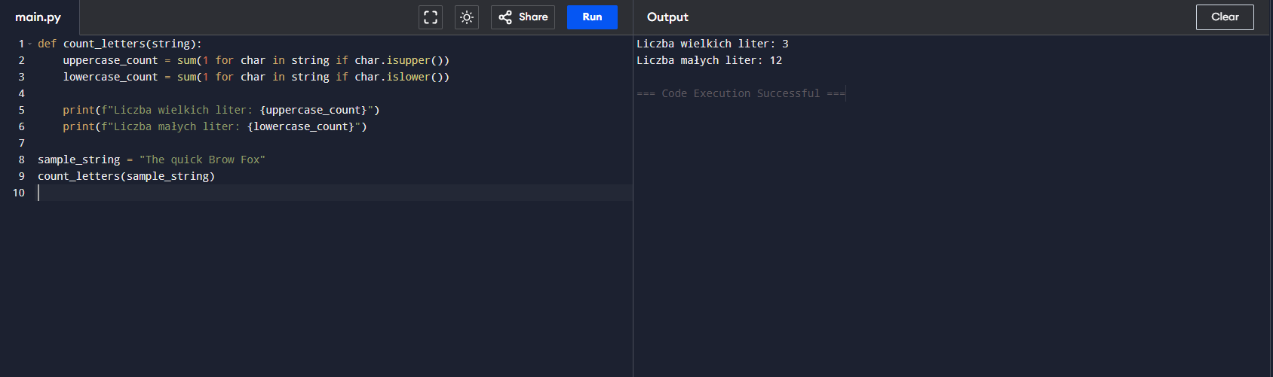

Code:

def count_letters(string):

uppercase_count = sum(1 for char in string if char.isupper())

lowercase_count = sum(1 for char in string if char.islower())

print(f"Liczba wielkich liter: {uppercase_count}")

print(f"Liczba małych liter: {lowercase_count}")

sample_string = "The quick Brow Fox"

count_letters(sample_string)

**Ćwiczenie 4**

Code:

class FindPair:

def __init__(self, numbers, target):

self.numbers = numbers

self.target = target

def find_indices(self):

seen = {}

for i, num in enumerate(self.numbers):

complement = self.target - num

if complement in seen:

return seen[complement], i

seen[num] = i

return None

numbers = [10, 20, 10, 40, 50, 60, 70]

target = 50

finder = FindPair(numbers, target)

result = finder.find_indices()

if result:

print(f"Wyjście: {result[0]}, {result[1]}")

else:

print("Nie znaleziono pary")

**Zadanie Quiz:**

**1. Plik quiz.py:**

from flask import Flask, render_template, request, redirect, url_for, flash

app = Flask(__name__)

app.config.update(dict(SECRET_KEY='bradzsecretvalue'))

DANE = [

{'question': 'Stolica Hiszpanii:', 'answers': ['Madryt', 'Warszawa', 'Barcelona'], 'correct': 'Madryt'},

{'question': 'Objętość sześcianu o boku 6 cm wynosi:', 'answers': ['36', '216', '18'], 'correct': '216'},

{'question': 'Symbol pierwiastka Hel:', 'answers': ['Fe', 'X', 'He'], 'correct': 'He'},

]

@app.route('/', methods=['GET', 'POST'])

def index():

if request.method == 'POST':

points = 0

answers = request.form

for pnr, answer in answers.items():

if answer == DANE[int(pnr)]['correct']:

points += 1

flash(f'Liczba poprawnych odpowiedzi: {points}')

return redirect(url_for('index'))

return render_template('index.html', questions=DANE)

if __name__ == '__main__':

app.run(debug=True)

**2. Plik templates/index.html:**

<!DOCTYPE html>

<html lang="pl">

<head>

<meta charset="UTF-8">

<meta name="viewport" content="width=device-width, initial-scale=1.0">

<title>Quiz z Pythona</title>

</head>

<body>

<h1>Quiz z Pythona</h1>

<p>

{% for message in get_flashed_messages() %}

{{ message }}

{% endfor %}

</p>

<form method="POST">

{% for p in questions %}

<p>

<b>{{ p['question'] }}</b><br>

{% set pnr = loop.index0 %}

{% for answer in p['answers'] %}

<label>

<input type="radio" name="{{ pnr }}" value="{{ answer }}">

{{ answer }}

</label><br>

{% endfor %}

</p>

{% endfor %}

<button type="submit">Sprawdź odpowiedzi</button>

</form>

</body>

</html>